|  |
| --- |
| **RTS-11 (14pin chassis mount) Nixie Röhren Fassung/ Nixie Tube Socket** |

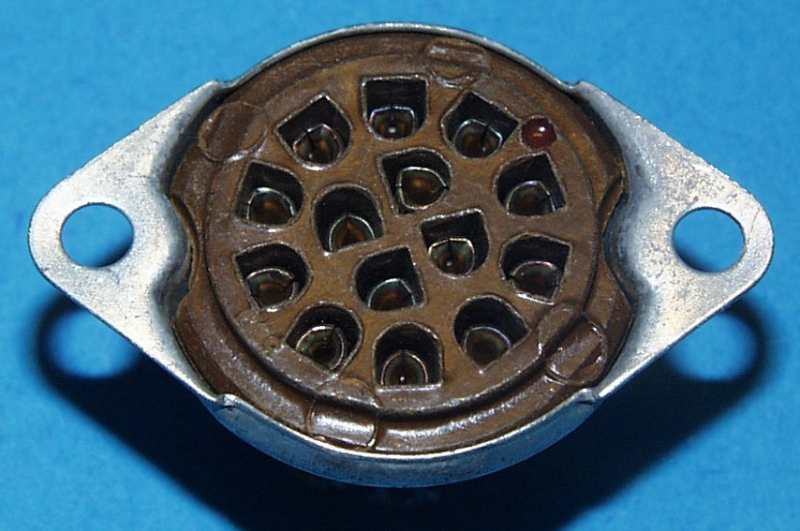

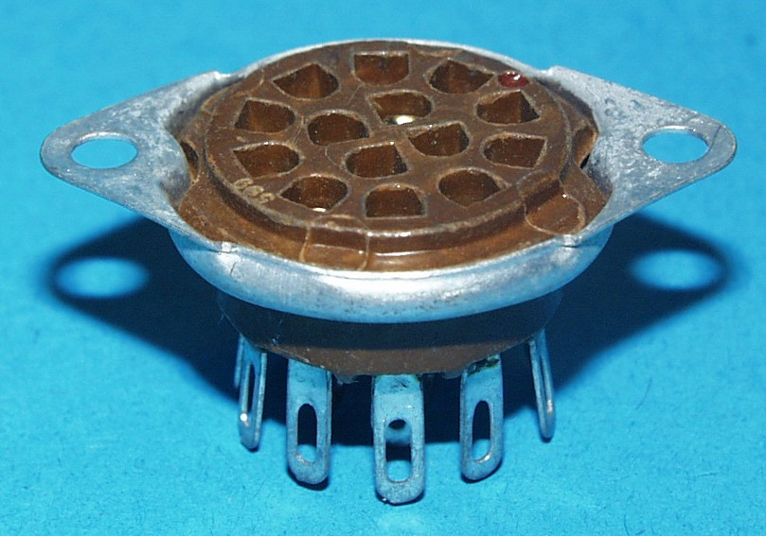

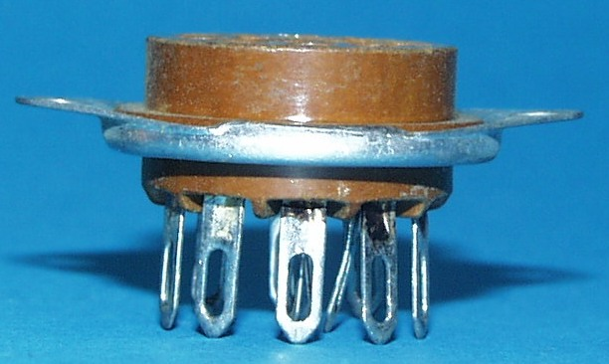

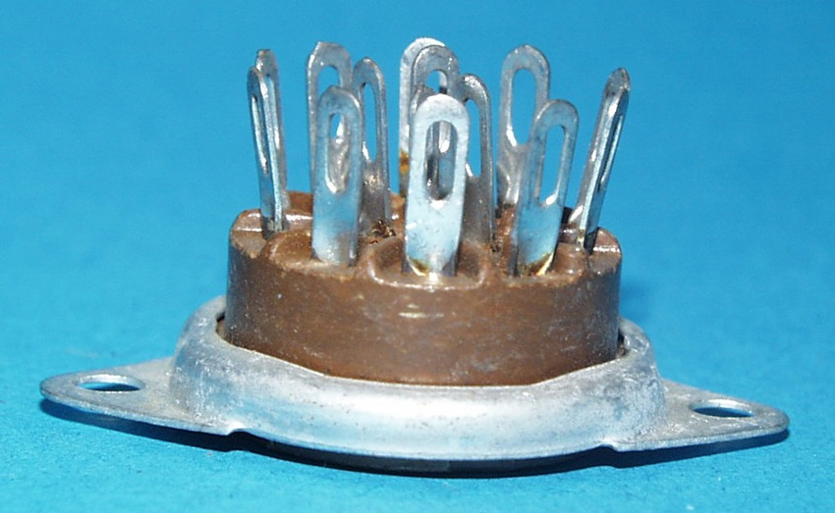

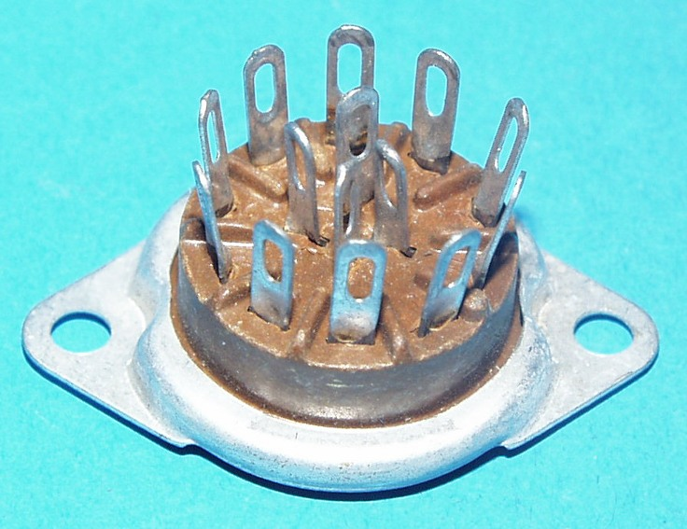

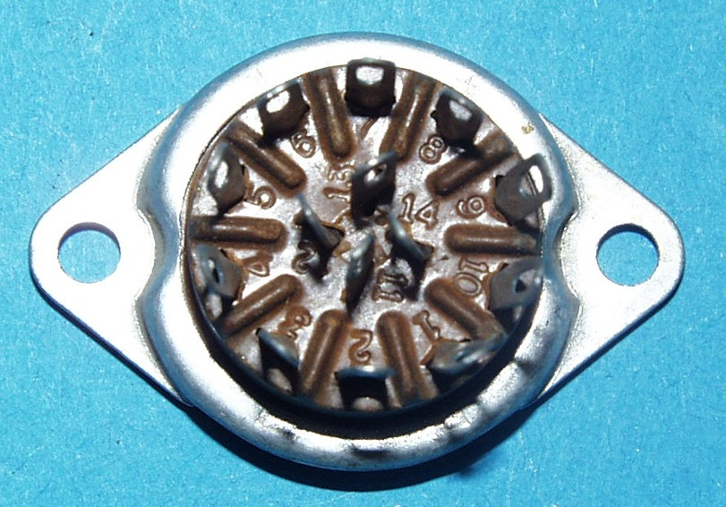

**RTS-11 Sockel- Beispiel/  
RTS-11 Base example:**

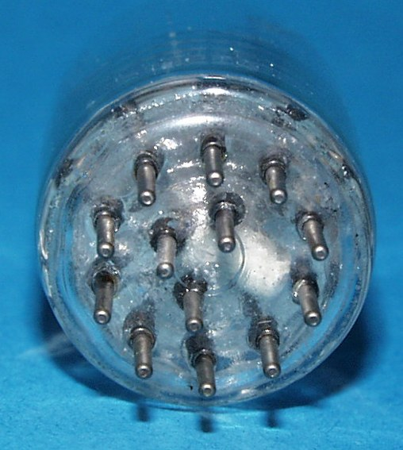

**Pinout:**

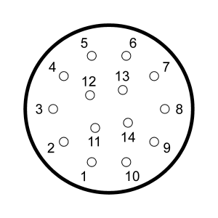  
Pinout graphic by Alan Franzman  
Ansicht von unten / Bottom view(底视图)  
  
**Outline:**

**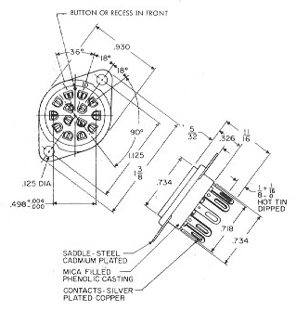  
  
Physical Characteristics:**

|  |  |  |
| --- | --- | --- |
| **German** | **English** |  |
| Anzahl der Pins | Number of Pins | 14 socket. 12, 13 or 14 tube |
| Hersteller | Brand | unknown |
| Typ | Type | RTS-11 |
| für Sockel | for base | RTS-11 |
| Äußerer Pinkreis- Durchmesser | Outer Pin Circle Diameter  （外插针圆直径） | 12.7mm (0.500") |
| Innerer Pinkreis- Durchmesser | Inner Pin Circle Diameter  （内插针圆直径） | 5.4mm (0.212") |
| Pin- Durchmesser | Pin Diameter（插针直径） | 1.02mm (0.040") |
| Äußerer Pin- Abstand | Pin Spacing (Outer Circle) | 10 × 36° |
| Innerer Pin- Abstand | Pin Spacing (Inner Circle) | 4 × 90° |
| Vergleichstypen | Substitudes | RTS-14, RTS-18, RTS-47, RTS-48, RTS-49, RTS-50 |

**This tube sockets fit for the following Nixie and readout tubes (examples!):**

**340-0004; 340-0005; 4200840; 4200841; 7193; 8754; CK1905; CK1907; CK1916; CK1917; CK1918; CK1922; CK8754; NL-803; NL-807; NL-811; NL-812; NL-814; NL-821; NL-840; NL-841; NL-842; NL-842PT; NL-843; NL-844; NL-845; NL-846; NL-847; NL-848; NL-856; NL-864; NL-867; NL-874; NL-875; NL-876; NL-884; NL-900; NL-901; NL-902; NL-903; NL-904; NL-905; NL-906; NL-907; NL-908; NL-939; NL-943; NL-973.**  
and many others!